**Author: Ndubuisi Ezeluomba**

**The Zaria Art Society**

Formed in 1958 by a group of undergraduate students in the Fine Art department of the Nigerian College of Arts, Science and Technology (later renamed Ahmadu Bello University, Zaria), the Zaria Art Society was an ideological group that rejected the modes of teaching and producing art at the institution. Sometimes referred to as the ‘Zaria Rebels’, the group’s impetus was hinged around the euphoria of pre- and post- independence nationalism of the time, but also the need to create new art. The idea that underpinned the formation of the Zaria Art Society was predicated on Uche Okeke’s enunciation of Natural Synthesis. As a concept, Natural Synthesis advocated the fusion of indigenous visual arts with useful western ones. This was central to the Zaria Art Society’s ideology. These artists created works that reflected the diverse cultures of the Nigerian state.

Members of the Zaria Art Society were concerned with the increasing influence of foreign cultural values and traditions on art in Nigeria, and the consequent erasure or denial of local artistic traditions and ideas. Thus, the concept of ‘Natural Synthesis’ was conceived and advocated by the group’s founder, Uche Okeke. Members of the group, including Bruce Onobrakpeya, Demas Nwoko, Yusuf Grillo, Simon Okeke, Jimoh Akolo, Oseloka Osadebe, and Emmanuel Odita, responded to the ideas set forth by creating works that reflected the diverse cultures of the Nigerian state. While Demas Nwoko created sculptures akin to the famous Nok sculptures, Uche Okeke made ink line drawings that echoed traditional *Uli* and *Ichi* body art among the Igbo of southeastern Nigeria. Bruce Onobrakpeya developed the plastocasts printing technique, through which he explored the ideas and folklore of his Urhobo people of Nigeria’s delta region.

The Society was short-lived; at the graduation of the pioneer members and their subsequent dispersal around the country and abroad, it was abandoned. Finally, through their involvement in art teaching and intellection, members of the group became influential in nurturing subsequent generations of Nigerian artists, and contributed to the development of modern Nigerian art. Despite the Zaria Art Society’s brief three-year life span, the group’s members went on to pursue artistic and academic careers that would leave a lasting legacy in the history of modern Nigerian art.

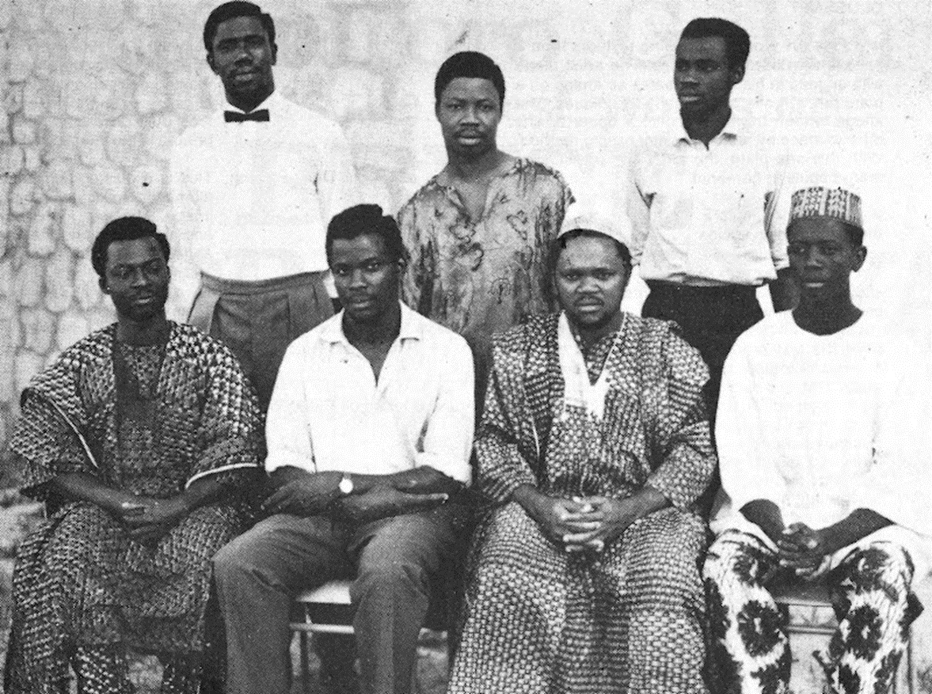

(Sitting, left to right), Bruce Onobrakpeya, Yusuf Grillo, Uche Okeke and Demas Nwoko. (Back row) Oseluka Osadebe, Late Nwagbara and Emmanuel Okechukwu Odita, all seven of the eight early members of Zaria Art Society. Photo: c/o Bruce Onobrakpeya Foundation.

<http://africanartswithtaj.blogspot.ch/2012/08/at-80-onobrakpeya-says-todays.html>

**References for further reading:**

Adepegba, C. O. (1995) *Nigerian Art: Its traditions and modern tendencies,* Ibadan: Jodad Publishers.

Filani, E. O. (2003) ‘Zaria Art Society and the Imperative of Historical Articulation’, *Triumph of a Vision: an Anthology on Uche Okeke and Modern Art in Nigeria.* 133-143.

Okeke, C. (1999) ‘The Quest for a Nigerian Art: Or a Story of Art from Zaria to Nsukka’, *Reading the Contemporary: African Art from Theory to the Marketplace*. Olu Oguibe and Okwui Enwezor (ed)*.* London: InIVA, 144-165.